Experiment 8
Write a program to implement Linear Regression (LR) algorithm in python
Aim
To implement the Linear Regression (LR) algorithm in Python to predict the output value based on the given input data.

Program
# Linear Regression in Python
import pandas as pd
from sklearn.linear_model import LinearRegression
from sklearn.metrics import mean_squared_error
# Dataset given directly
data = {
'Hours': [1, 2, 3, 4, 5],
'Marks': [20, 40, 50, 65, 80]
}
df = pd.DataFrame(data)
# Features and target
X = df[['Hours']]
y = df['Marks']
# Create model
model = LinearRegression()
# Train model
model.fit(X, y)
# Predict
y_pred = model.predict(X)
print("Actual Marks:", list(y))
print("Predicted Marks:", list(y_pred))
# Mean Squared Error
mse = mean_squared_error(y, y_pred)
print("Mean Squared Error:", mse)
Output
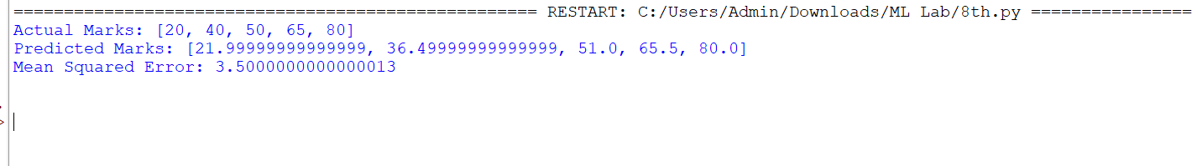

Result
The Linear Regression algorithm was successfully implemented in Python to predict output values based on input data.

